Triangle Centers
# Source: AI Source: Provided by: [Data Path: Persons Table -> ID Column: 1, Name_En Column: Motasem Essam] -> From: [ChatGPT] on [7/25/2026]
A triangle has several important points called triangle centers. The four most important are:
- Triangle Centroid
- Triangle Incenter
- Triangle Circumcenter
- Triangle Orthocenter
Each center is defined by a different set of lines or geometric properties.

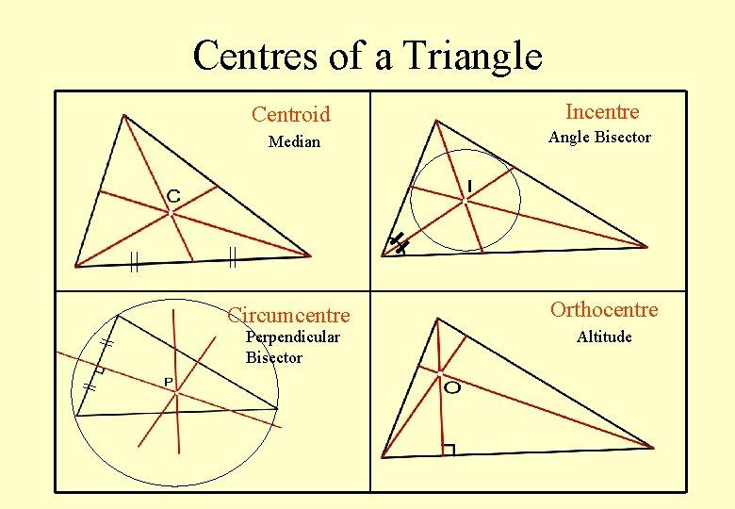
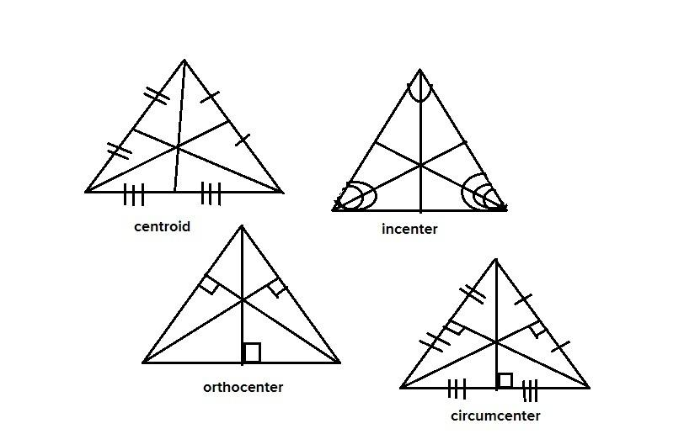
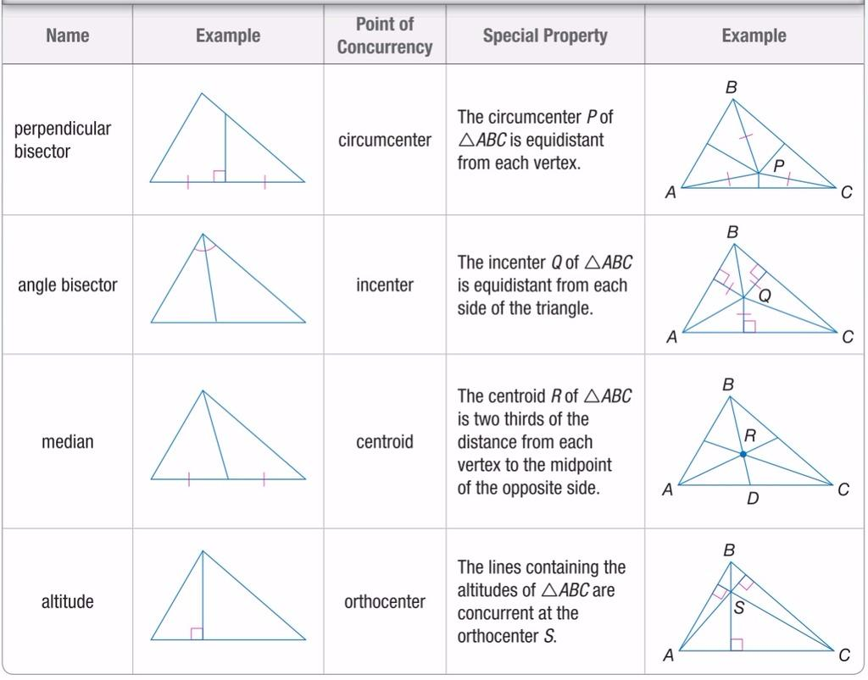

1. Triangle Centroid

Definition
# Source: AI Source: Provided by: [Data Path: Persons Table -> ID Column: 1, Name_En Column: Motasem Essam] -> From: [ChatGPT] on [7/25/2026]
The centroid of a triangle is the point where its three medians intersect.
A median connects a vertex to the midpoint of the opposite side.
The centroid is usually labeled:
$$\boxed{G}$$
If the medians are $AD$, $BE$, and $CF$, then:
$\boxed{AD∩BE∩CF=G}$
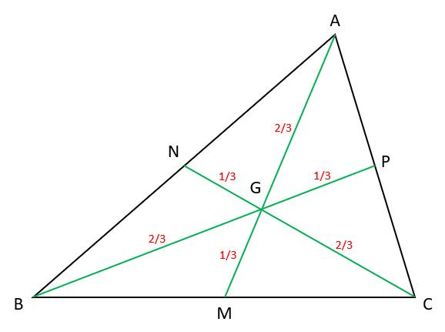
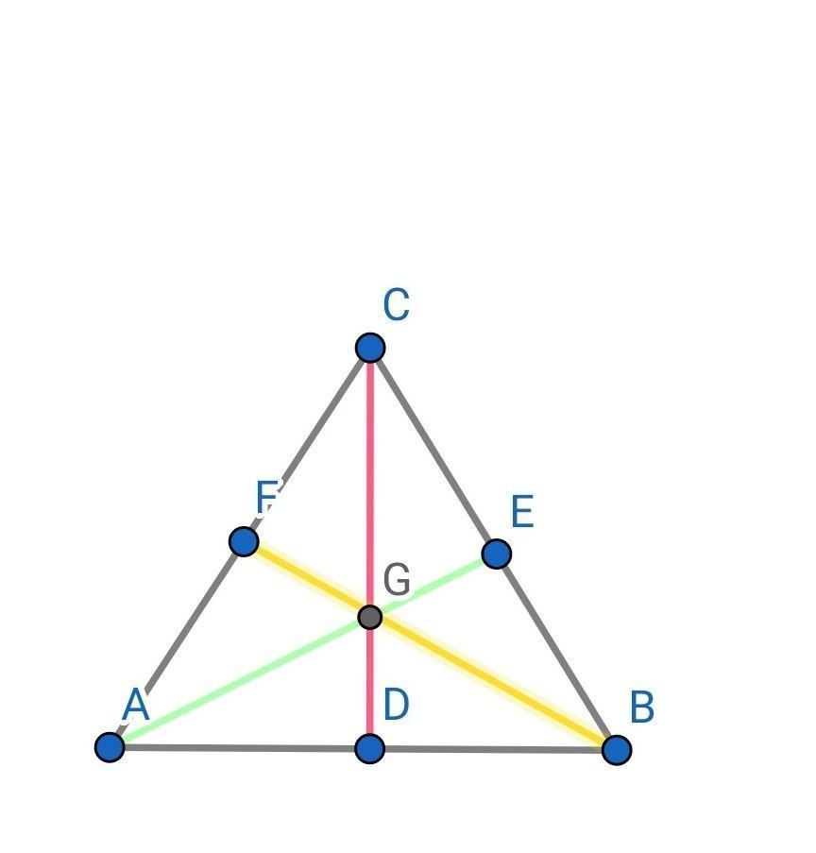
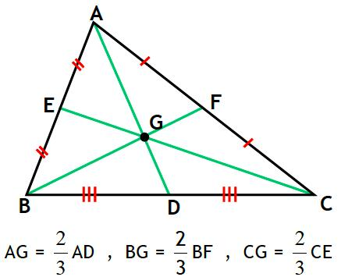

Main Properties

Three medians intersect at one point
# Source: AI Source: Provided by: [Data Path: Persons Table -> ID Column: 1, Name_En Column: Motasem Essam] -> From: [ChatGPT] on [7/25/2026]
Every triangle has three medians, and they are always concurrent at $G$.

The centroid divides each median in a $2:1$ ratio
# Source: AI Source: Provided by: [Data Path: Persons Table -> ID Column: 1, Name_En Column: Motasem Essam] -> From: [ChatGPT] on [7/25/2026]
For median $AD$:
$$\boxed{AG:GD=2:1}$$
Therefore:
$$AG=\frac{2}{3}AD$$
and:
$$GD=\frac{1}{3}AD$$

Coordinate Formula
# Source: AI Source: Provided by: [Data Path: Persons Table -> ID Column: 1, Name_En Column: Motasem Essam] -> From: [ChatGPT] on [7/25/2026]
If:
$$A(x_{1},y_{1}), B(x_{2},y_{2}), C(x_{3},y_{3})$$
then:
$$\boxed{G=\left(\frac{x_{1}+x_{2}+x_{3}}{3},\frac{y_{1}+y_{2}+y_{3}}{3}\right)}$$

Physical Meaning
# Source: AI Source: Provided by: [Data Path: Persons Table -> ID Column: 1, Name_En Column: Motasem Essam] -> From: [ChatGPT] on [7/25/2026]
For a uniform triangular plate, the centroid is its center of mass.

2. Triangle Incenter

Definition
# Source: AI Source: Provided by: [Data Path: Persons Table -> ID Column: 1, Name_En Column: Motasem Essam] -> From: [ChatGPT] on [7/25/2026]
The incenter of a triangle is the point where the three internal angle bisectors intersect.
The incenter is usually labeled:
$$\boxed{I}$$
If the angle bisectors intersect at $I$:
$\boxed{I=\text{intersection of the three angle bisectors}}$
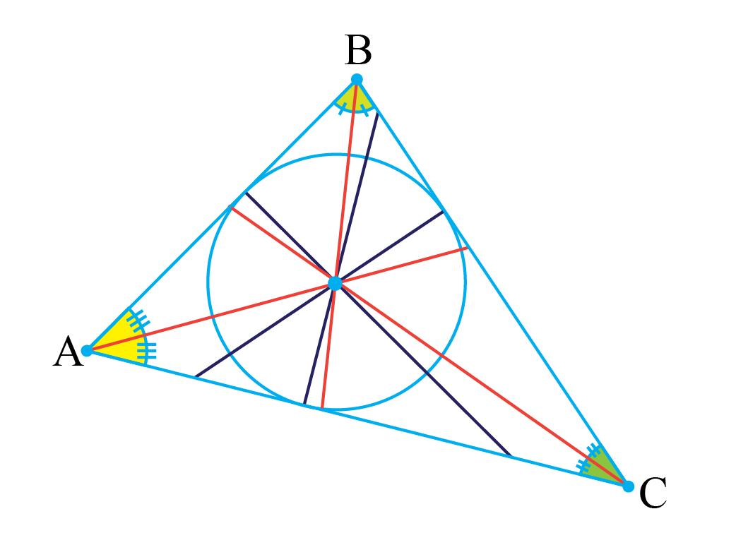
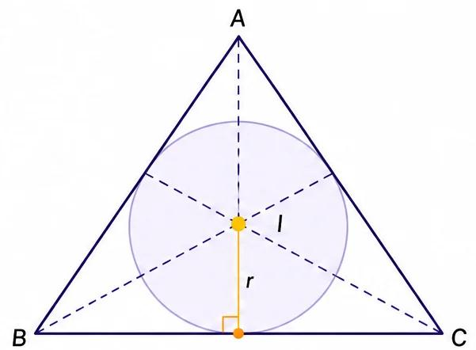
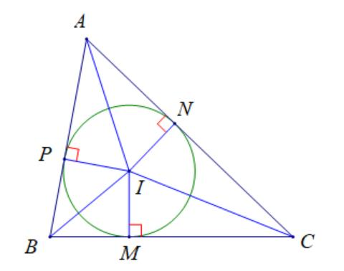
5

Main Properties

1. It is equidistant from all three sides
# Source: AI Source: Provided by: [Data Path: Persons Table -> ID Column: 1, Name_En Column: Motasem Essam] -> From: [ChatGPT] on [7/25/2026]
If the perpendicular distances from $I$ to the three sides are $r$, then:
$$\boxed{d(I,AB)=d(I,BC)=d(I,CA)=r}$$

2. It is the center of the incircle
# Source: AI Source: Provided by: [Data Path: Persons Table -> ID Column: 1, Name_En Column: Motasem Essam] -> From: [ChatGPT] on [7/25/2026]
The circle centered at $I$ and tangent to all three sides is called the incircle.
Its radius is called the inradius:
$$\boxed{r}$$

3. It always lies inside the triangle
# Source: AI Source: Provided by: [Data Path: Persons Table -> ID Column: 1, Name_En Column: Motasem Essam] -> From: [ChatGPT] on [7/25/2026]
Unlike some other triangle centers, the incenter is always inside the triangle.

Inradius and Area
# Source: AI Source: Provided by: [Data Path: Persons Table -> ID Column: 1, Name_En Column: Motasem Essam] -> From: [ChatGPT] on [7/25/2026]
The area of a triangle can be expressed using the inradius:
$$\boxed{A=rs}$$
where:
- $A$ = area
- $r$ = inradius
- $s$ = semiperimeter
Since:
$$s=\frac{a+b+c}{2}$$
we can find:
$$\boxed{r=\frac{A}{s}}$$

3. Triangle Circumcenter

Definition
# Source: AI Source: Provided by: [Data Path: Persons Table -> ID Column: 1, Name_En Column: Motasem Essam] -> From: [ChatGPT] on [7/25/2026]
The circumcenter of a triangle is the point where the perpendicular bisectors of the three sides intersect.
It is usually labeled:
$\boxed{O}$
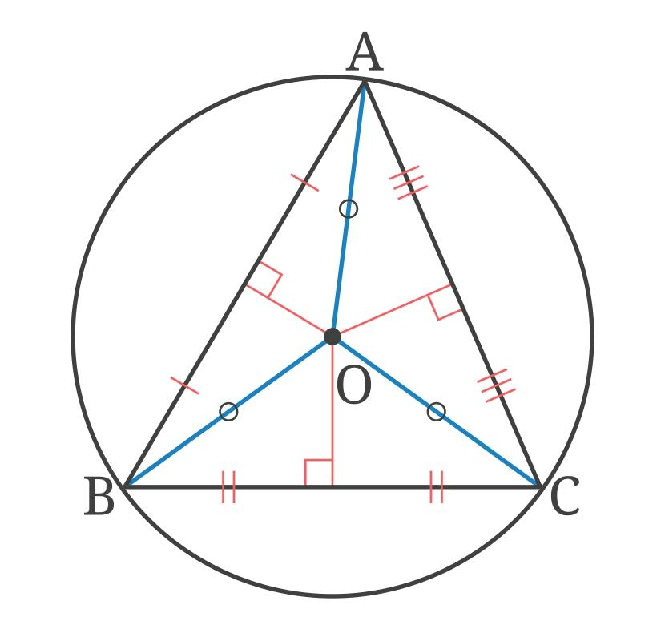
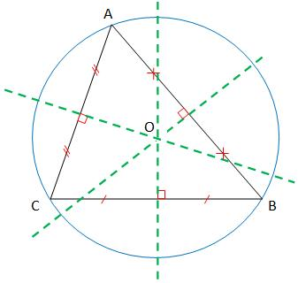
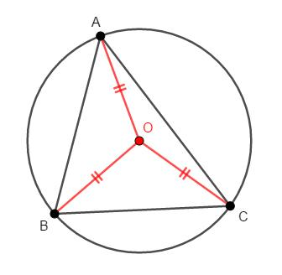
4

Main Properties

1. It is equidistant from all three vertices
# Source: AI Source: Provided by: [Data Path: Persons Table -> ID Column: 1, Name_En Column: Motasem Essam] -> From: [ChatGPT] on [7/25/2026]
If $O$ is the circumcenter:
$$\boxed{OA=OB=OC}$$
This common distance is called the circumradius:
$$\boxed{R}$$

2. It is the center of the circumcircle
# Source: AI Source: Provided by: [Data Path: Persons Table -> ID Column: 1, Name_En Column: Motasem Essam] -> From: [ChatGPT] on [7/25/2026]
The circle passing through all three vertices is called the circumcircle.
Therefore:
$$\boxed{OA=OB=OC=R}$$

3. It is the intersection of perpendicular bisectors
# Source: AI Source: Provided by: [Data Path: Persons Table -> ID Column: 1, Name_En Column: Motasem Essam] -> From: [ChatGPT] on [7/25/2026]
If the perpendicular bisectors of $AB$, $BC$, and $CA$ are drawn, they meet at $O$.

Location of the Circumcenter
# Source: AI Source: Provided by: [Data Path: Persons Table -> ID Column: 1, Name_En Column: Motasem Essam] -> From: [ChatGPT] on [7/25/2026]
The circumcenter's position depends on the triangle type:
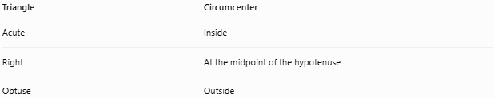
Triangle | Circumcenter
Acute | Inside
Right | At the midpoint of the hypotenuse
Obtuse | Outside

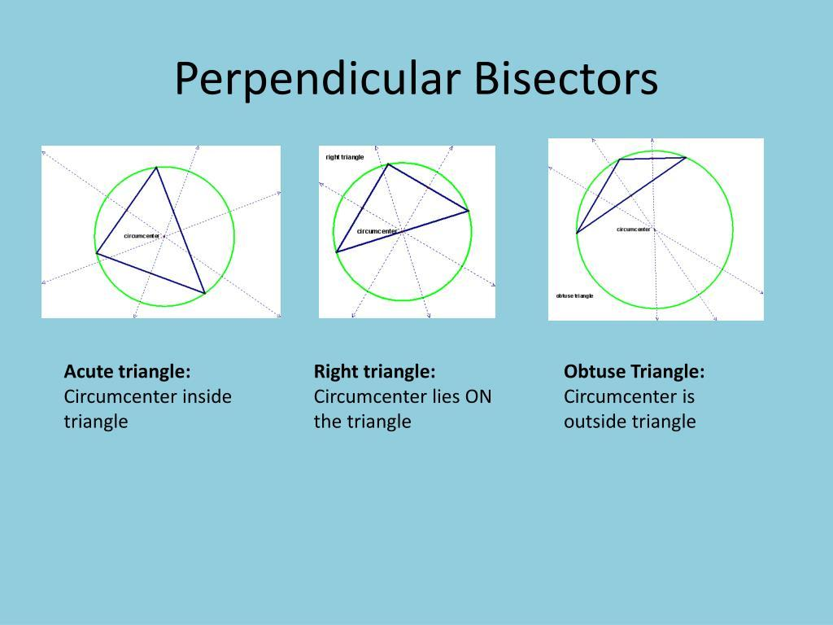
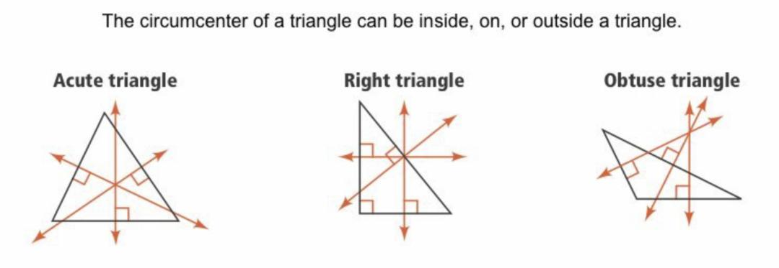
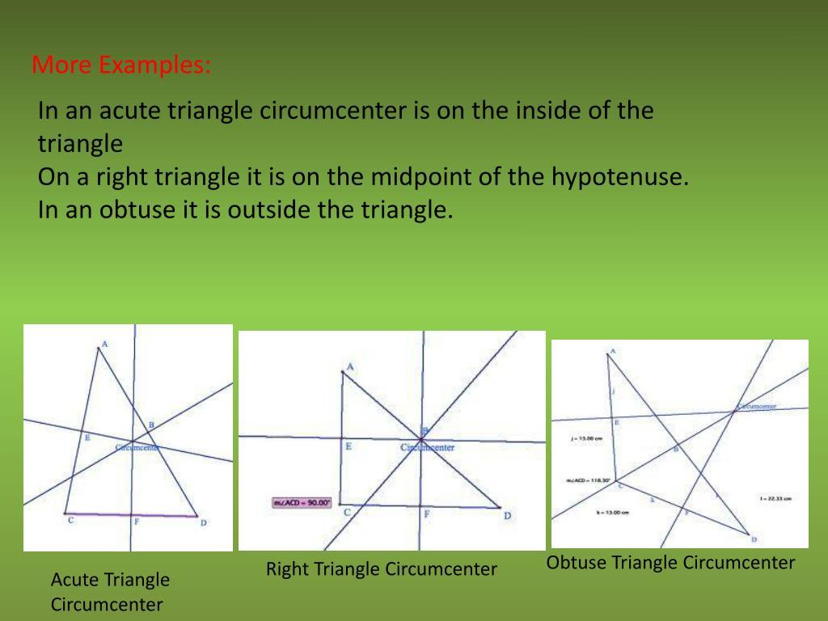

Right Triangle
# Source: AI Source: Provided by: [Data Path: Persons Table -> ID Column: 1, Name_En Column: Motasem Essam] -> From: [ChatGPT] on [7/25/2026]
For a right triangle:
$$\boxed{O=\text{midpoint of hypotenuse}}$$
Therefore, the circumradius is:
$$\boxed{R=\frac{c}{2}}$$
where $c$ is the hypotenuse.

4. Triangle Orthocenter

Definition
# Source: AI Source: Provided by: [Data Path: Persons Table -> ID Column: 1, Name_En Column: Motasem Essam] -> From: [ChatGPT] on [7/25/2026]
The orthocenter of a triangle is the point where the three altitudes intersect.
It is usually labeled:
$$\boxed{H}$$
An altitude is a perpendicular segment from a vertex to the line containing the opposite side.
Therefore:
$\boxed{H=\text{intersection of the three altitudes}}$
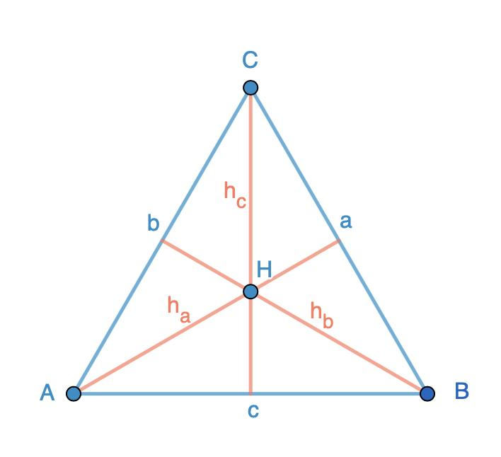
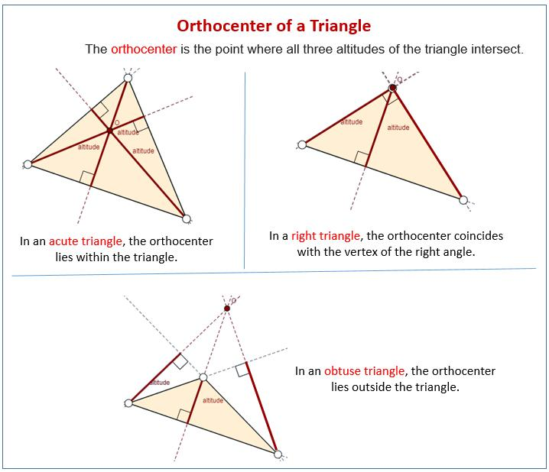
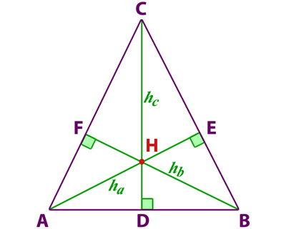
4

Main Properties

Three altitudes are concurrent
# Source: AI Source: Provided by: [Data Path: Persons Table -> ID Column: 1, Name_En Column: Motasem Essam] -> From: [ChatGPT] on [7/25/2026]
The three altitudes always intersect at a single point:
$$\boxed{AD∩BE∩CF=H}$$
where $AD$, $BE$, and $CF$ are the altitudes.

Location
# Source: AI Source: Provided by: [Data Path: Persons Table -> ID Column: 1, Name_En Column: Motasem Essam] -> From: [ChatGPT] on [7/25/2026]
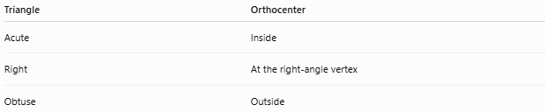
Triangle | Orthocenter
Acute | Inside
Right | At the right-angle vertex
Obtuse | Outside

Right Triangle
# Source: AI Source: Provided by: [Data Path: Persons Table -> ID Column: 1, Name_En Column: Motasem Essam] -> From: [ChatGPT] on [7/25/2026]
If $ABC$ is right-angled at $A$:
$$\boxed{H=A}$$
because the two legs themselves are altitudes.

Comparison of the Four Triangle Centers
# Source: AI Source: Provided by: [Data Path: Persons Table -> ID Column: 1, Name_En Column: Motasem Essam] -> From: [ChatGPT] on [7/25/2026]
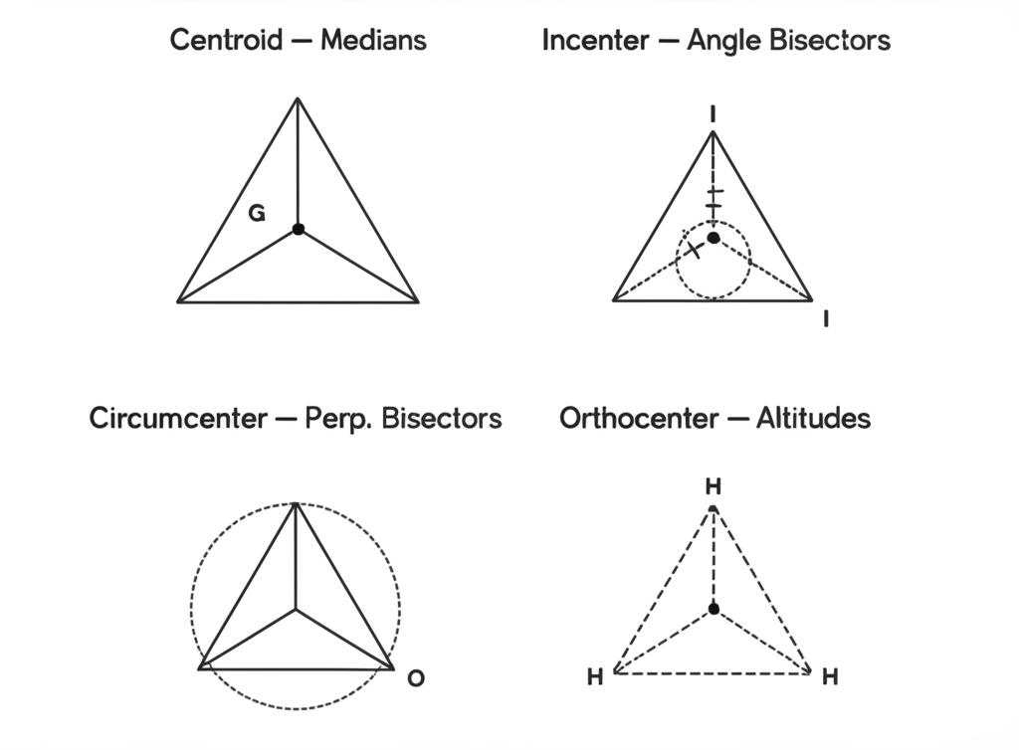
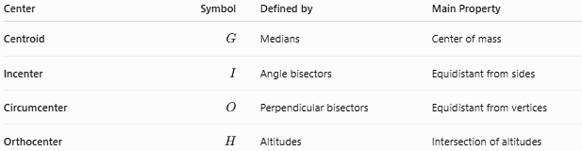
Center | Symbol | Defined by | Main Property
Centroid | $$G$$ | Medians | Center of mass
Incenter | $$I$$ | Angle bisectors | Equidistant from sides
Circumcenter | $$O$$ | Perpendicular bisectors | Equidistant from vertices
Orthocenter | $$H$$ | Altitudes | Intersection of altitudes

The Four Centers and Their Lines
# Source: AI Source: Provided by: [Data Path: Persons Table -> ID Column: 1, Name_En Column: Motasem Essam] -> From: [ChatGPT] on [7/25/2026]
There is a useful way to remember them:
$\boxed{\text{Median}→\text{Centroid}}$ $\boxed{\text{Angle Bisector}→\text{Incenter}}$ $\boxed{\text{Perpendicular Bisector}→\text{Circumcenter}}$ $\boxed{\text{Altitude}→\text{Orthocenter}}$

Coordinate Formulas
# Source: AI Source: Provided by: [Data Path: Persons Table -> ID Column: 1, Name_En Column: Motasem Essam] -> From: [ChatGPT] on [7/25/2026]
For:
$$A(x_{1},y_{1}), B(x_{2},y_{2}), C(x_{3},y_{3})$$

Centroid
# Source: AI Source: Provided by: [Data Path: Persons Table -> ID Column: 1, Name_En Column: Motasem Essam] -> From: [ChatGPT] on [7/25/2026]
$$\boxed{G=\left(\frac{x_{1}+x_{2}+x_{3}}{3},\frac{y_{1}+y_{2}+y_{3}}{3}\right)}$$

Incenter
# Source: AI Source: Provided by: [Data Path: Persons Table -> ID Column: 1, Name_En Column: Motasem Essam] -> From: [ChatGPT] on [7/25/2026]
If the side lengths opposite $A,B,C$ are $a,b,c$, respectively:
$$\boxed{I=\left(\frac{ax_{1}+bx_{2}+cx_{3}}{a+b+c},\frac{ay_{1}+by_{2}+cy_{3}}{a+b+c}\right)}$$

Circumcenter
# Source: AI Source: Provided by: [Data Path: Persons Table -> ID Column: 1, Name_En Column: Motasem Essam] -> From: [ChatGPT] on [7/25/2026]
The circumcenter is found by solving the equations of the perpendicular bisectors of two sides.

Orthocenter
# Source: AI Source: Provided by: [Data Path: Persons Table -> ID Column: 1, Name_En Column: Motasem Essam] -> From: [ChatGPT] on [7/25/2026]
The orthocenter is found by solving the equations of two altitudes.
Once the intersection is found, it automatically lies on the third altitude.

Special Case: Equilateral Triangle
# Source: AI Source: Provided by: [Data Path: Persons Table -> ID Column: 1, Name_En Column: Motasem Essam] -> From: [ChatGPT] on [7/25/2026]
An equilateral triangle is especially important because all four centers coincide.

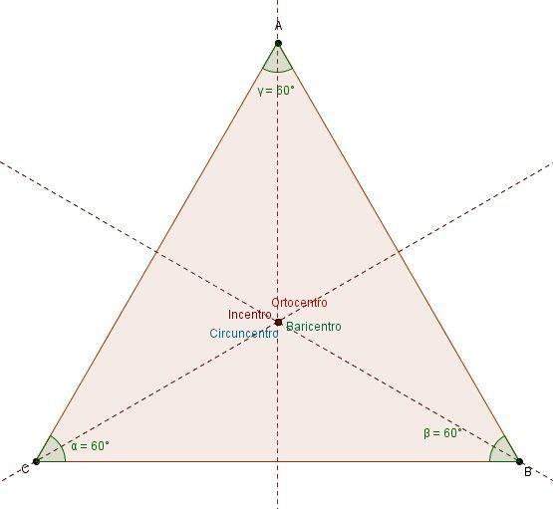
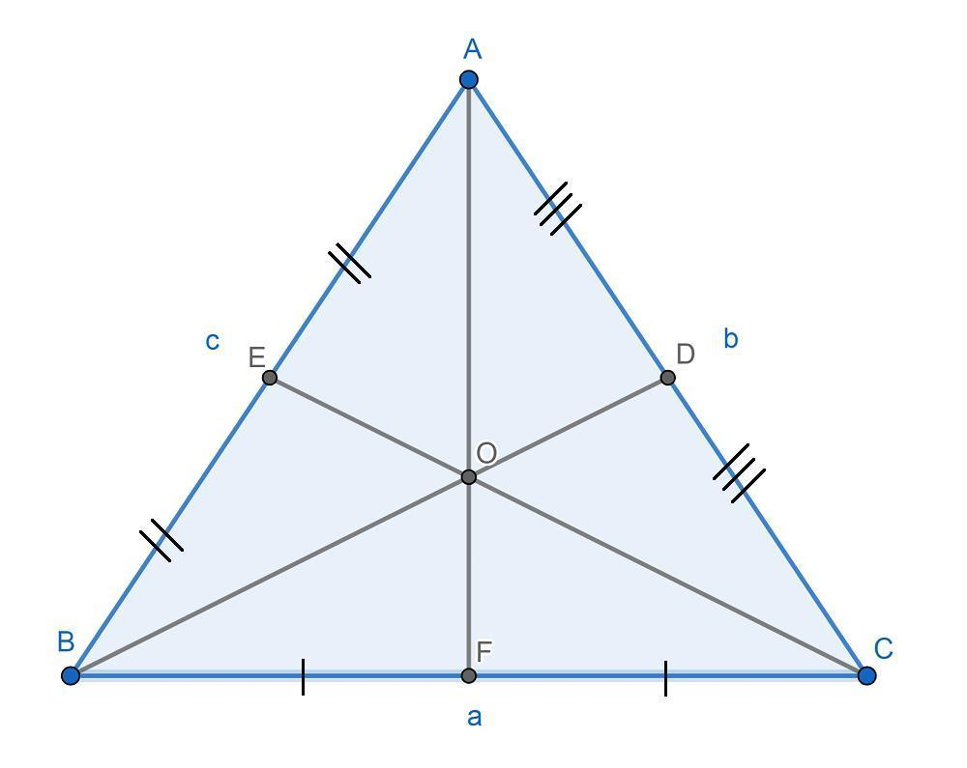
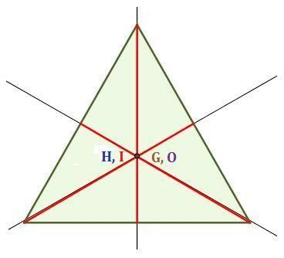
4
For an equilateral triangle:
$$\boxed{G=I=O=H}$$
The same point is simultaneously:
- Centroid
- Incenter
- Circumcenter
- Orthocenter
Also, the following lines coincide:
$$\boxed{\text{Median}=\text{Altitude}=\text{Angle Bisector}=\text{Perpendicular Bisector}}$$

Euler Line
# Source: AI Source: Provided by: [Data Path: Persons Table -> ID Column: 1, Name_En Column: Motasem Essam] -> From: [ChatGPT] on [7/25/2026]
For a general triangle, the centroid, circumcenter, and orthocenter lie on the same straight line called the Euler line.

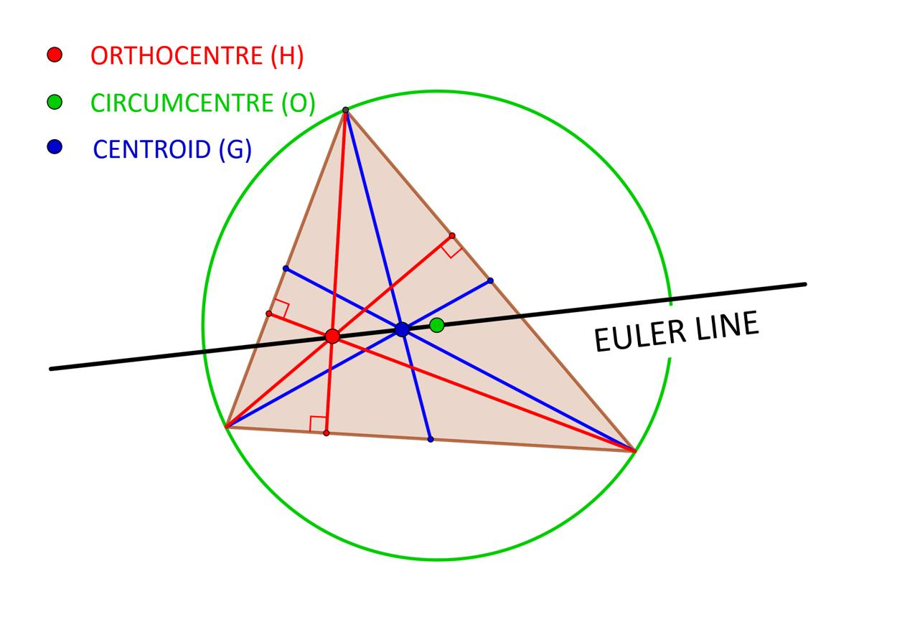
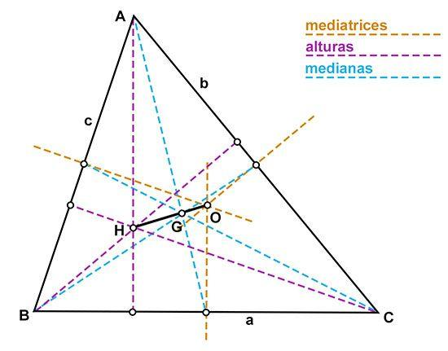
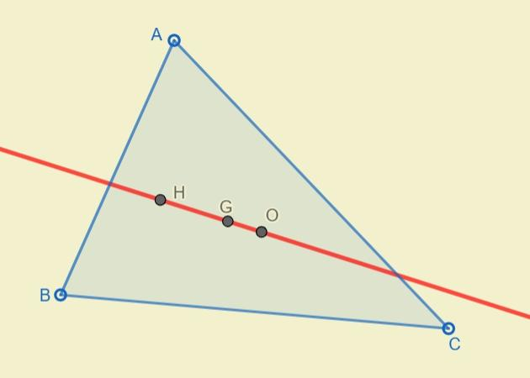
5
The relationship is:
$$\boxed{O, G, H\text{ are collinear}}$$
The centroid lies between the circumcenter and orthocenter in the usual non-equilateral case.
One important relation is:
$$\boxed{OG:GH=1:2}$$
or equivalently:
$$\boxed{OG=\frac{1}{3}OH}$$
The incenter $I$ generally does not lie on the Euler line.

Important Relationships

Centroid
# Source: AI Source: Provided by: [Data Path: Persons Table -> ID Column: 1, Name_En Column: Motasem Essam] -> From: [ChatGPT] on [7/25/2026]
Based on:
$$\boxed{\text{Medians}}$$
and:
$$\boxed{AG:GD=2:1}$$

Incenter
# Source: AI Source: Provided by: [Data Path: Persons Table -> ID Column: 1, Name_En Column: Motasem Essam] -> From: [ChatGPT] on [7/25/2026]
Based on:
$$\boxed{\text{Angle Bisectors}}$$
and:
$$\boxed{d(I,AB)=d(I,BC)=d(I,CA)}$$

Circumcenter
# Source: AI Source: Provided by: [Data Path: Persons Table -> ID Column: 1, Name_En Column: Motasem Essam] -> From: [ChatGPT] on [7/25/2026]
Based on:
$$\boxed{\text{Perpendicular Bisectors}}$$
and:
$$\boxed{OA=OB=OC}$$

Orthocenter
# Source: AI Source: Provided by: [Data Path: Persons Table -> ID Column: 1, Name_En Column: Motasem Essam] -> From: [ChatGPT] on [7/25/2026]
Based on:
$$\boxed{\text{Altitudes}}$$
and:
$$\boxed{\text{Three Altitudes Intersect at }H}$$

Example
# Source: AI Source: Provided by: [Data Path: Persons Table -> ID Column: 1, Name_En Column: Motasem Essam] -> From: [ChatGPT] on [7/25/2026]
Consider an equilateral triangle $ABC$.
Because it is equilateral:
$$AB=BC=CA$$
Every median is also an altitude, angle bisector, and perpendicular bisector.
Therefore, all four centers are the same point:
$$\boxed{G=I=O=H}$$
This is a special property of an equilateral triangle and does not generally happen in a scalene triangle.

Real-World Applications

Centroid
# Source: AI Source: Provided by: [Data Path: Persons Table -> ID Column: 1, Name_En Column: Motasem Essam] -> From: [ChatGPT] on [7/25/2026]
- Center of mass
- Structural balance
- Engineering
- Mechanical design

Incenter
# Source: AI Source: Provided by: [Data Path: Persons Table -> ID Column: 1, Name_En Column: Motasem Essam] -> From: [ChatGPT] on [7/25/2026]
- Designing tangent circles
- Inscribed circular structures
- Geometry constructions

Circumcenter
# Source: AI Source: Provided by: [Data Path: Persons Table -> ID Column: 1, Name_En Column: Motasem Essam] -> From: [ChatGPT] on [7/25/2026]
- Circular construction
- Surveying
- Finding a circle through three points
- Navigation and positioning

Orthocenter
# Source: AI Source: Provided by: [Data Path: Persons Table -> ID Column: 1, Name_En Column: Motasem Essam] -> From: [ChatGPT] on [7/25/2026]
- Triangle geometry
- Perpendicular-distance problems
- Engineering geometry
- Advanced geometric constructions

Advantages
# Source: AI Source: Provided by: [Data Path: Persons Table -> ID Column: 1, Name_En Column: Motasem Essam] -> From: [ChatGPT] on [7/25/2026]
These four centers provide powerful ways to analyze triangles:
- They give important reference points.
- They simplify geometric constructions.
- They connect different triangle segments.
- They provide useful formulas and ratios.
- They have applications in coordinate geometry and physics.
- They help classify and study special triangles.

Limitations
# Source: AI Source: Provided by: [Data Path: Persons Table -> ID Column: 1, Name_En Column: Motasem Essam] -> From: [ChatGPT] on [7/25/2026]
Each center is based on a different geometric construction:
- The centroid does not generally have equal distances to the sides or vertices.
- The incenter is not generally equidistant from the vertices.
- The circumcenter is not generally equidistant from the sides.
- The orthocenter is not generally a center of equal distances.
- The circumcenter and orthocenter can lie outside an obtuse triangle.

Key Points
# Source: AI Source: Provided by: [Data Path: Persons Table -> ID Column: 1, Name_En Column: Motasem Essam] -> From: [ChatGPT] on [7/25/2026]
- Centroid $G$ → intersection of the three medians.
- Incenter $I$ → intersection of the three angle bisectors.
- Circumcenter $O$ → intersection of the three perpendicular bisectors.
- Orthocenter $H$ → intersection of the three altitudes.

Easy memory rule
# Source: AI Source: Provided by: [Data Path: Persons Table -> ID Column: 1, Name_En Column: Motasem Essam] -> From: [ChatGPT] on [7/25/2026]
$$\boxed{\begin{matrix}\text{Medians}→G \\ \text{Angle Bisectors}→I \\ \text{Perpendicular Bisectors}→O \\ \text{Altitudes}→H\end{matrix}}$$
For an equilateral triangle:
$$\boxed{G=I=O=H}$$
For a general triangle:
$$\boxed{O, G, H\text{ lie on the Euler line}}$$

Conclusion
# Source: AI Source: Provided by: [Data Path: Persons Table -> ID Column: 1, Name_En Column: Motasem Essam] -> From: [ChatGPT] on [7/25/2026]
The centroid, incenter, circumcenter, and orthocenter are the four fundamental centers of a triangle. Each is associated with a different family of important lines: medians, angle bisectors, perpendicular bisectors, and altitudes. Understanding these four centers provides a foundation for studying triangle geometry, special triangles, circles, coordinate geometry, and advanced geometric relationships.

